Exercises

* Change the width and height of an image to 200 pixels both.
* Create an *OutlinedButton* widget that displays the text *Cancel*.
* Create a function called *cancel* that prints *Cancel button is clicked*, and pass it to the *onPressed* parameter of the *OutlinedButton* widget created in the previous step.
* Change the background color of the *OutlinedButton* widget to *Colors.purple*.
* Add a padding of 10 pixels to the *OutlinedButton* widget at the **top and bottom** only.
* Add a padding of 60 pixels to the *OutlinedButton* widget using *SizedBox* widget.
* 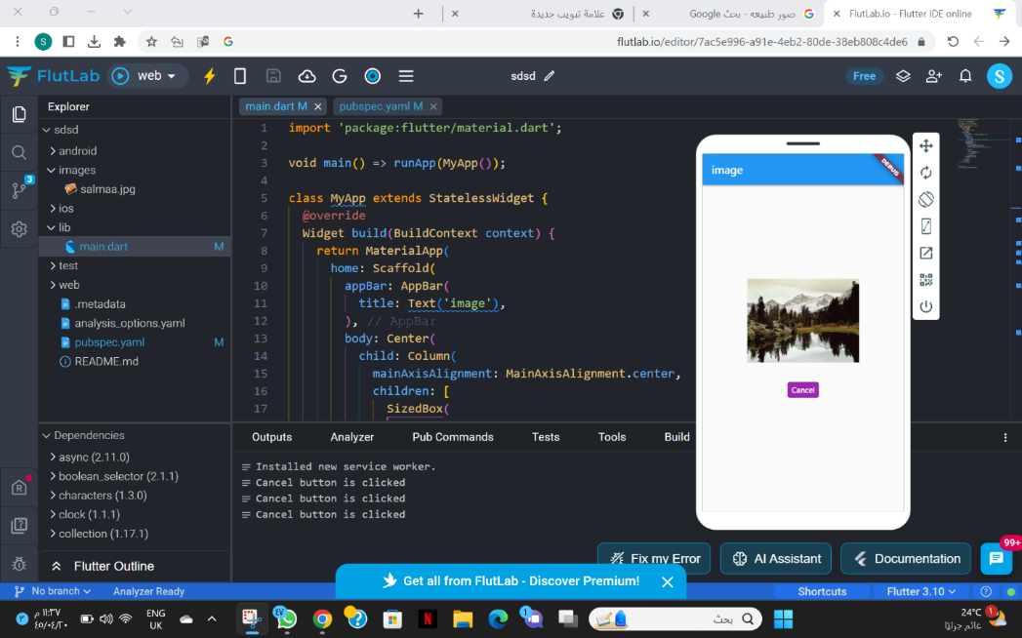
* import 'package:flutter/material.dart';
* void main() => runApp(MyApp());
* class MyApp extends StatelessWidget {
* @override
* Widget build(BuildContext context) {
* return MaterialApp(
* home: Scaffold(
* appBar: AppBar(
* title: Text('image'),
* ),
* body: Center(
* child: Column(
* mainAxisAlignment: MainAxisAlignment.center,
* children: [
* SizedBox(
* width: 200,
* height: 200,
* child: Image.asset('images/salmaa.jpg'),
* ),
* SizedBox(height: 10),
* OutlinedButton(
* onPressed: cancel,
* style: OutlinedButton.styleFrom(
* backgroundColor: Colors.purple,
* padding: EdgeInsets.symmetric(vertical: 10),
* ),
* child: Text(
* 'Cancel',
* style: TextStyle(
* color: Colors.white,
* ),
* ),
* ),
* SizedBox(height: 60),
* ],
* ),
* ),
* ),
* );
* }
* }
* void cancel() {
* print('Cancel button is clicked');
* }